**AWS Task-3**

**Task Description:**

1. **Create a S3 bucket, with no public access and upload files to the bucket & view the logs using cloudwatch for the uploaded files.**

* Created 2 buckets. One is to upload file another one is to view the logs

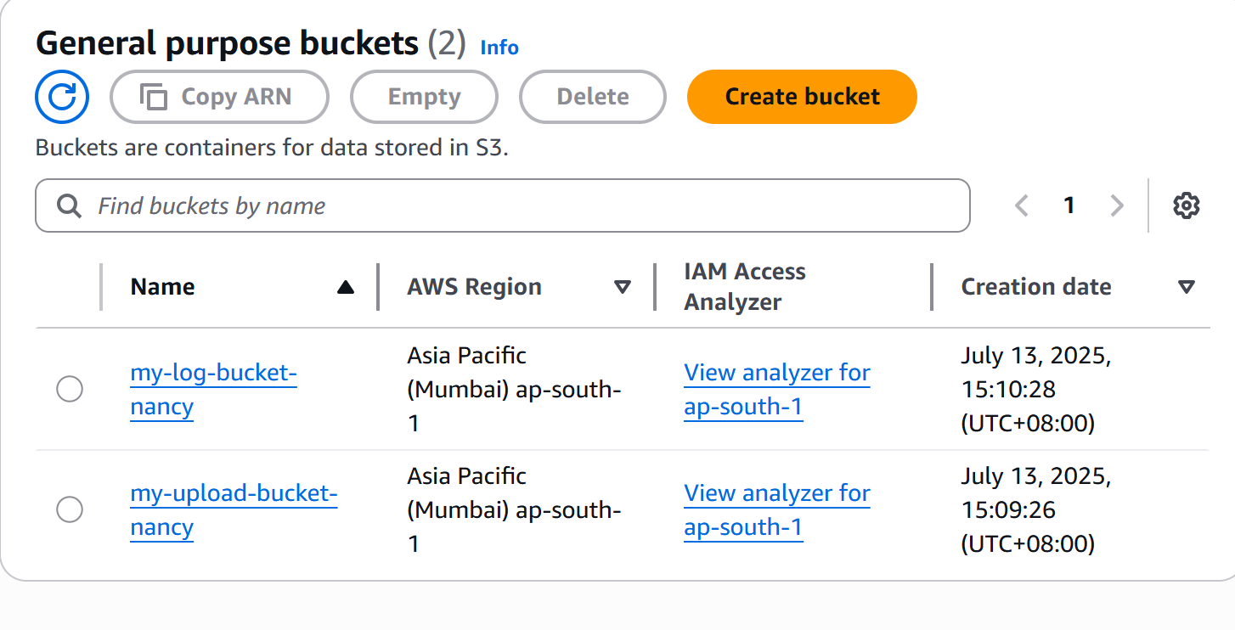

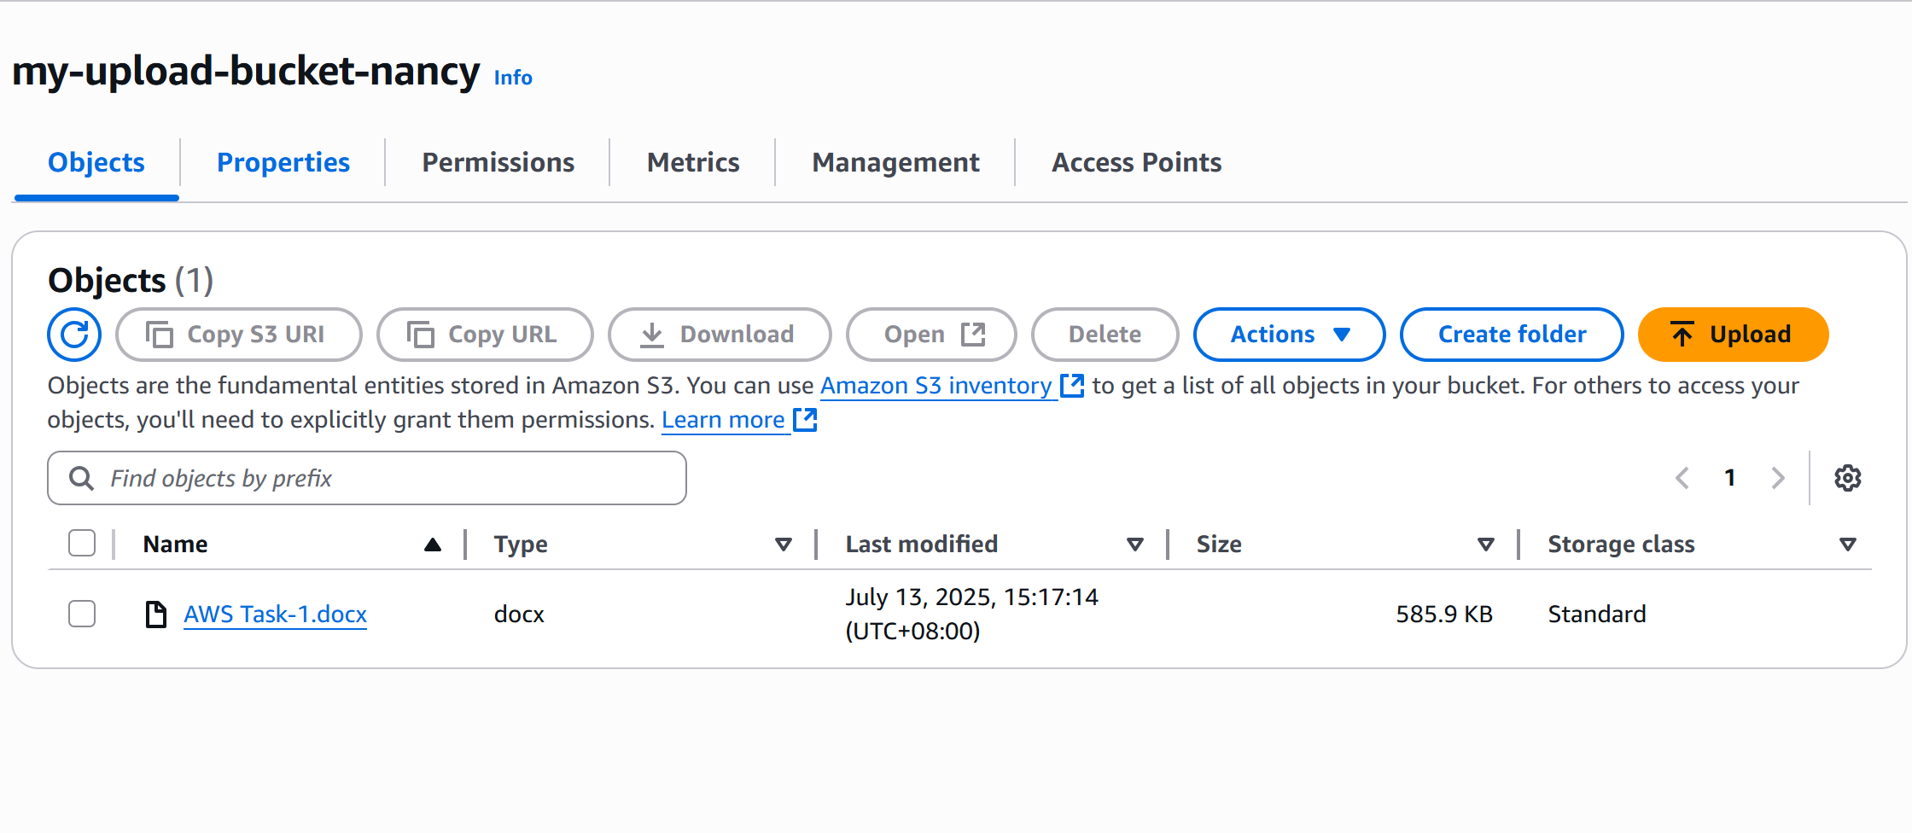

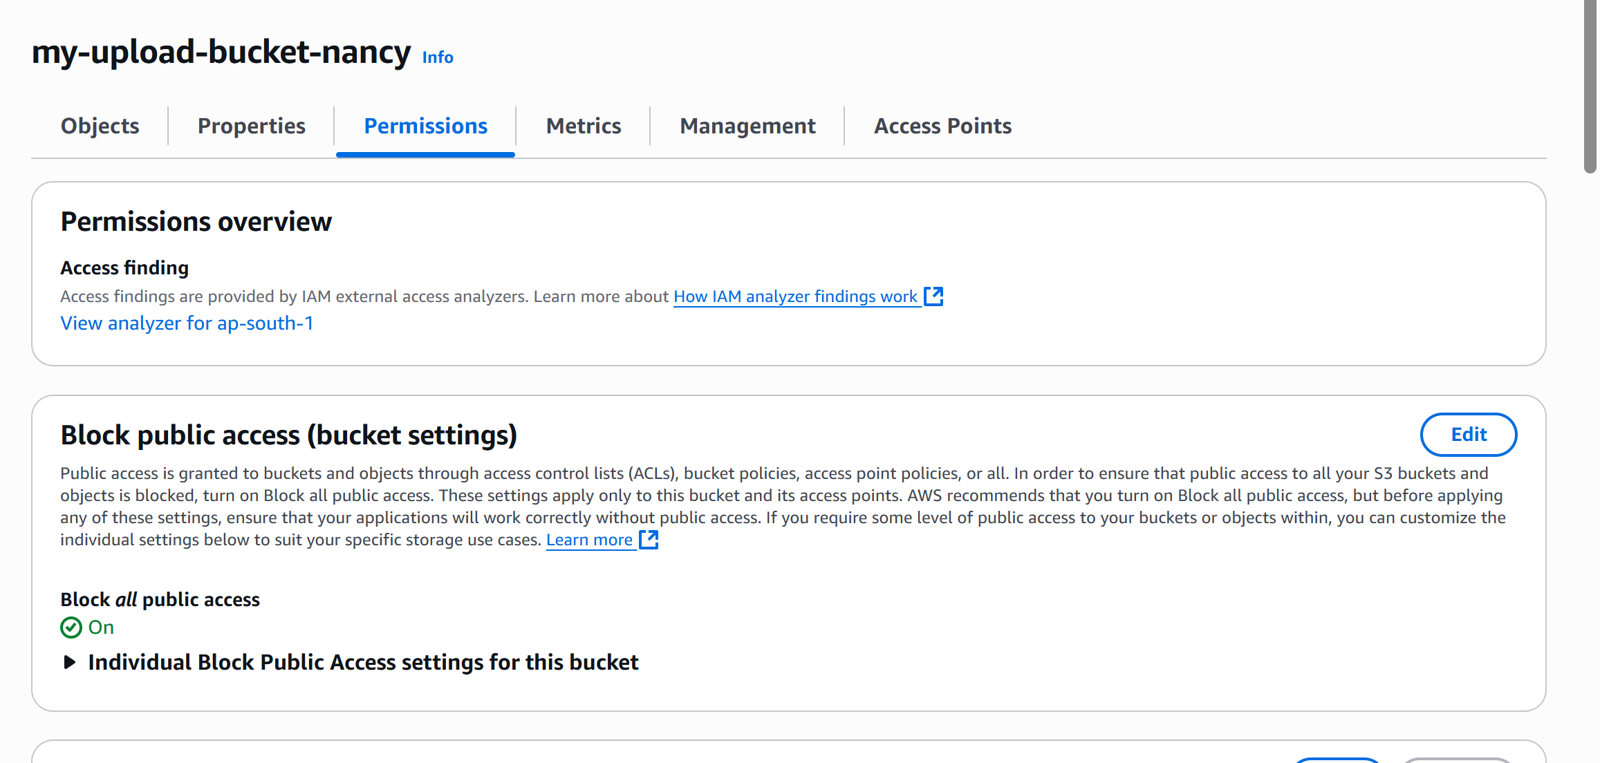

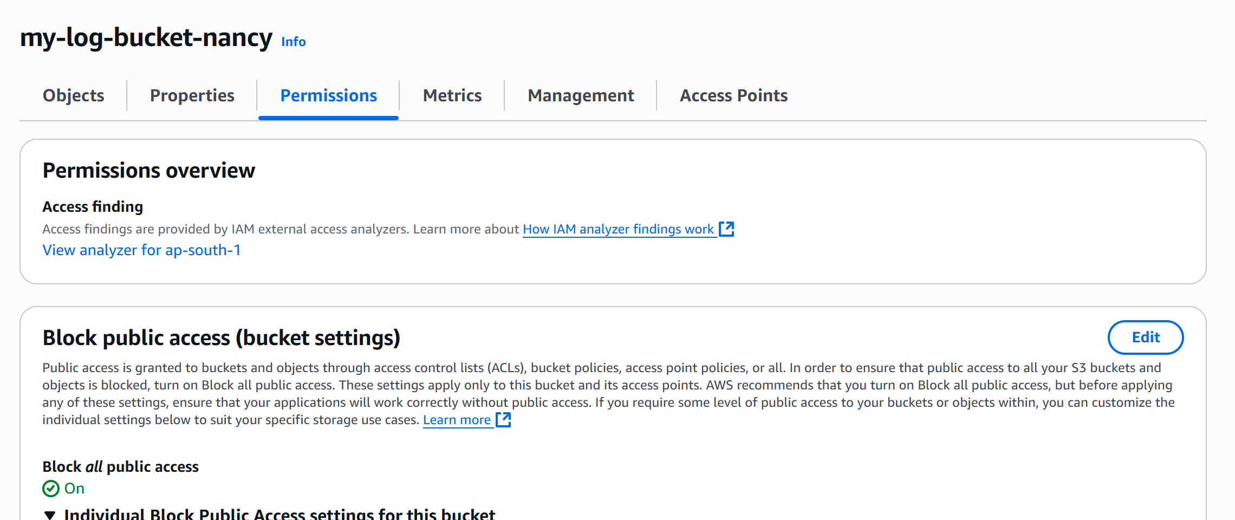

* Added bucket policy in log bucket

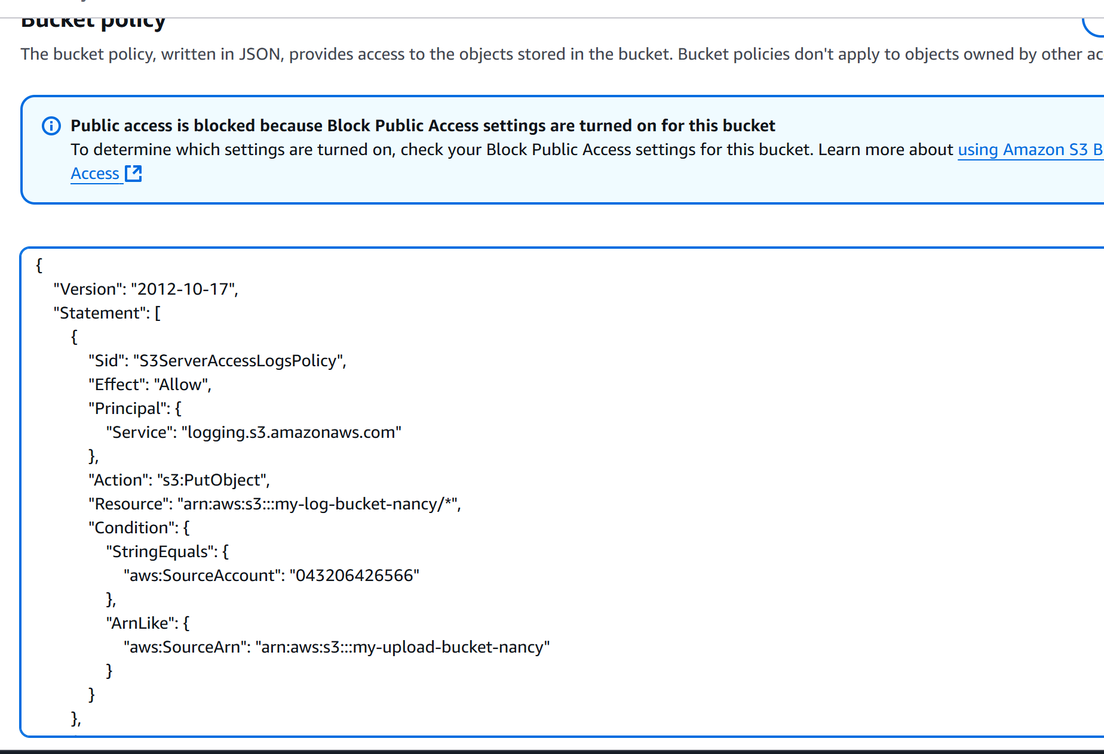

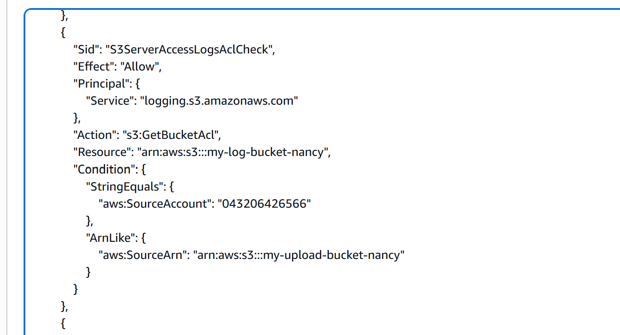

* Logs are shown in log bucket

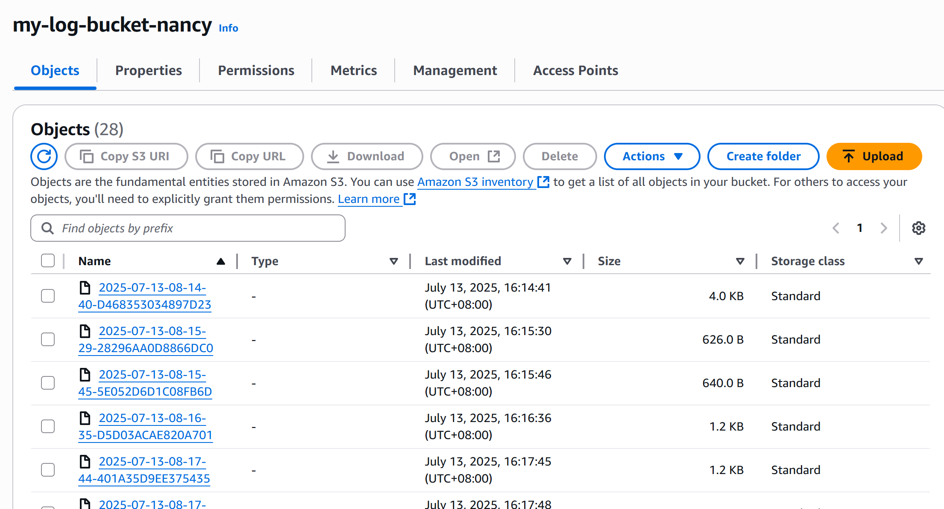

***Note: CloudWatch Topic was not covered yet, so created a bucket to view the logs***

1. **Launch two ec2-instances and connect it to a application load balancer, where the output traffic from the server must be an load balancer IP address**

Created Instance 1  
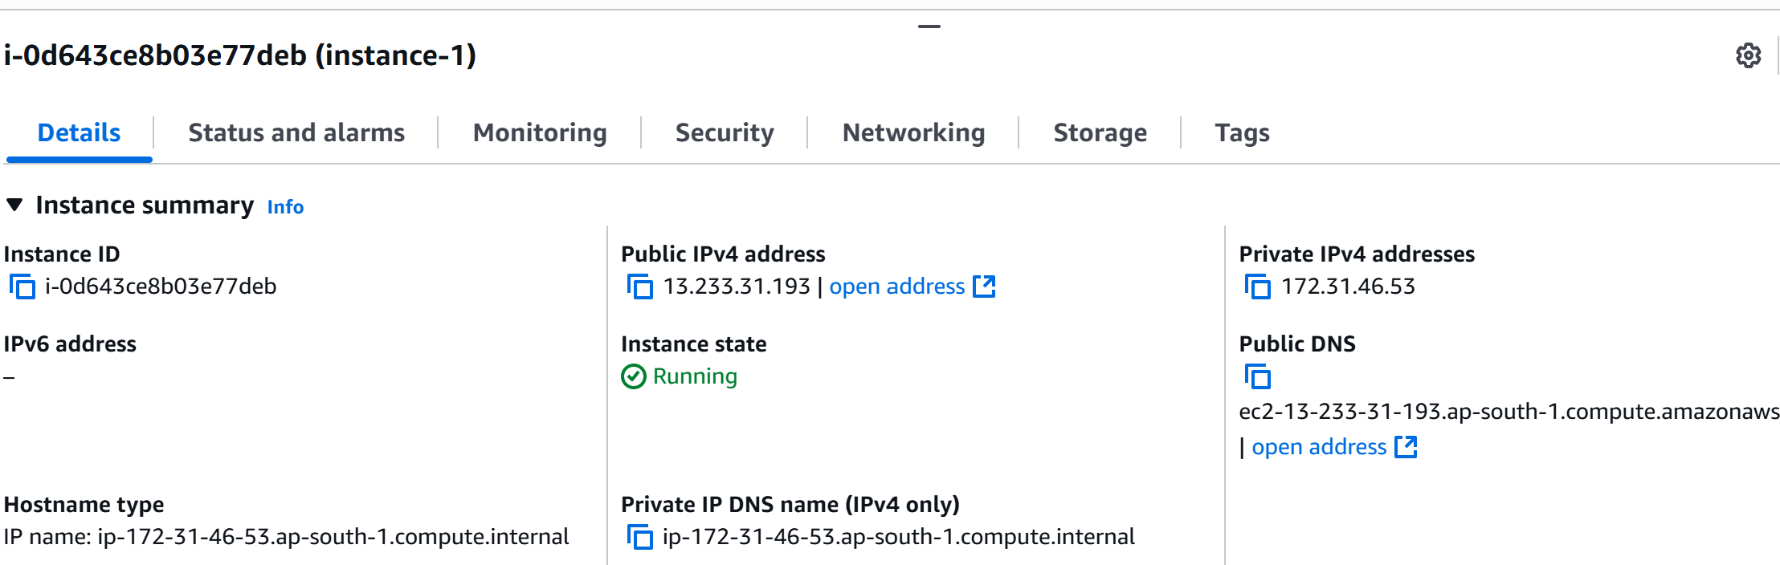

Allow port 80 in security group

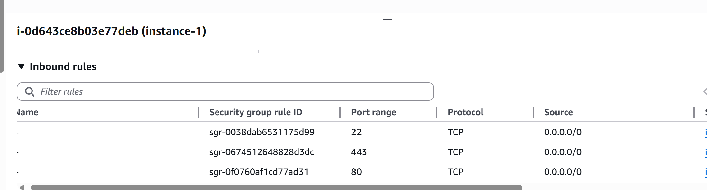

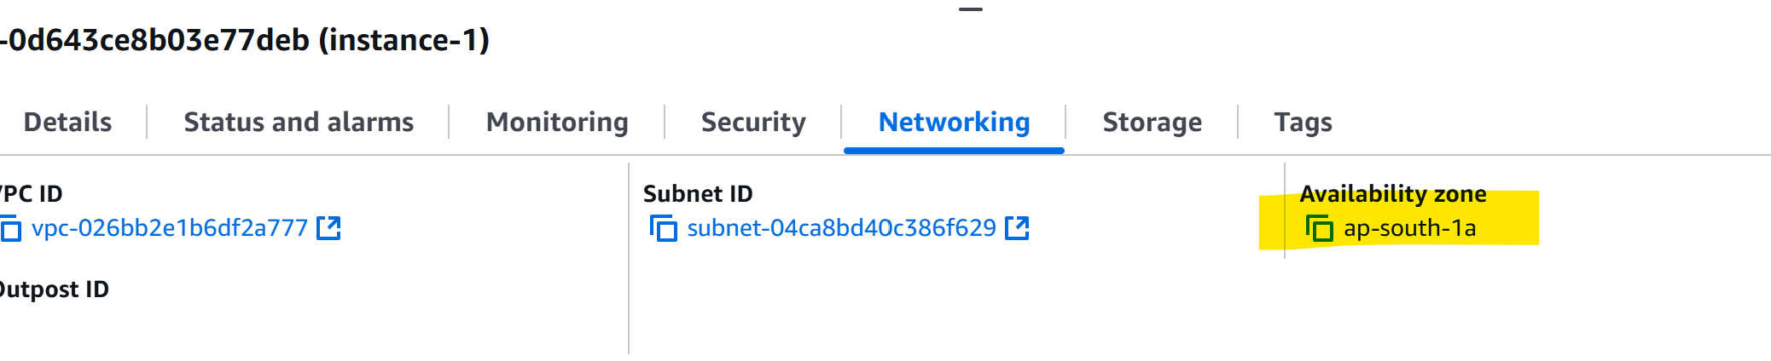

Installed APACHE web server in userdata

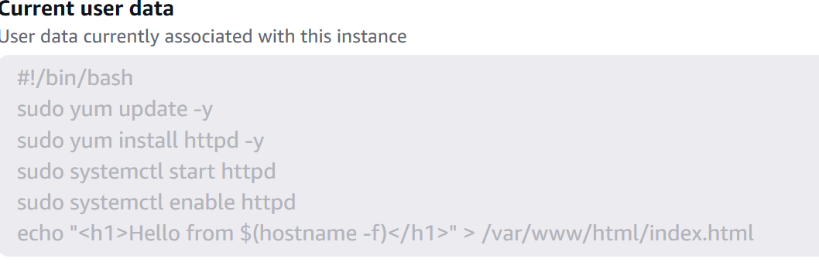

Modified the index.html inside instance

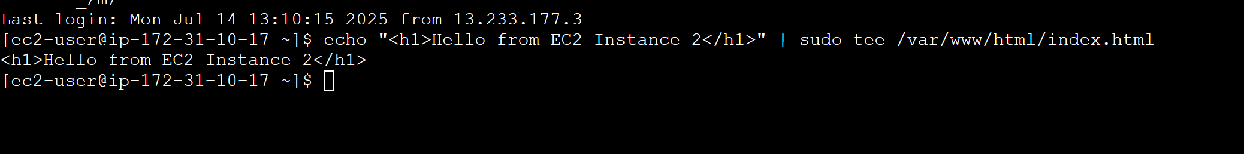

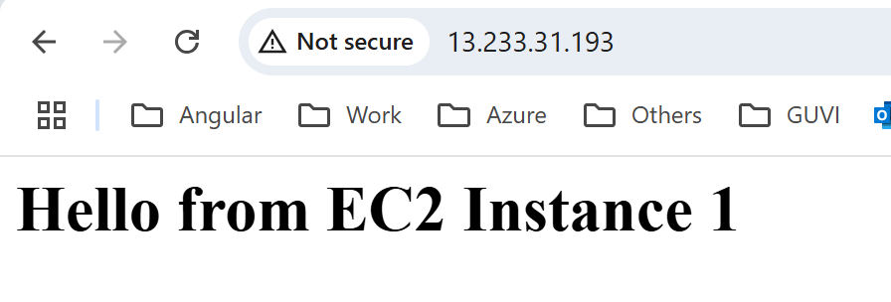

Instance 2

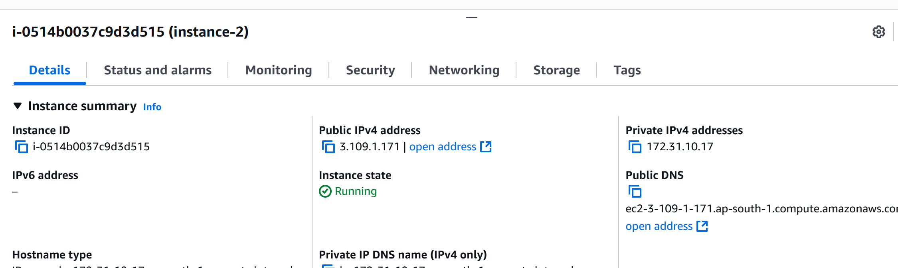

Allow port 80

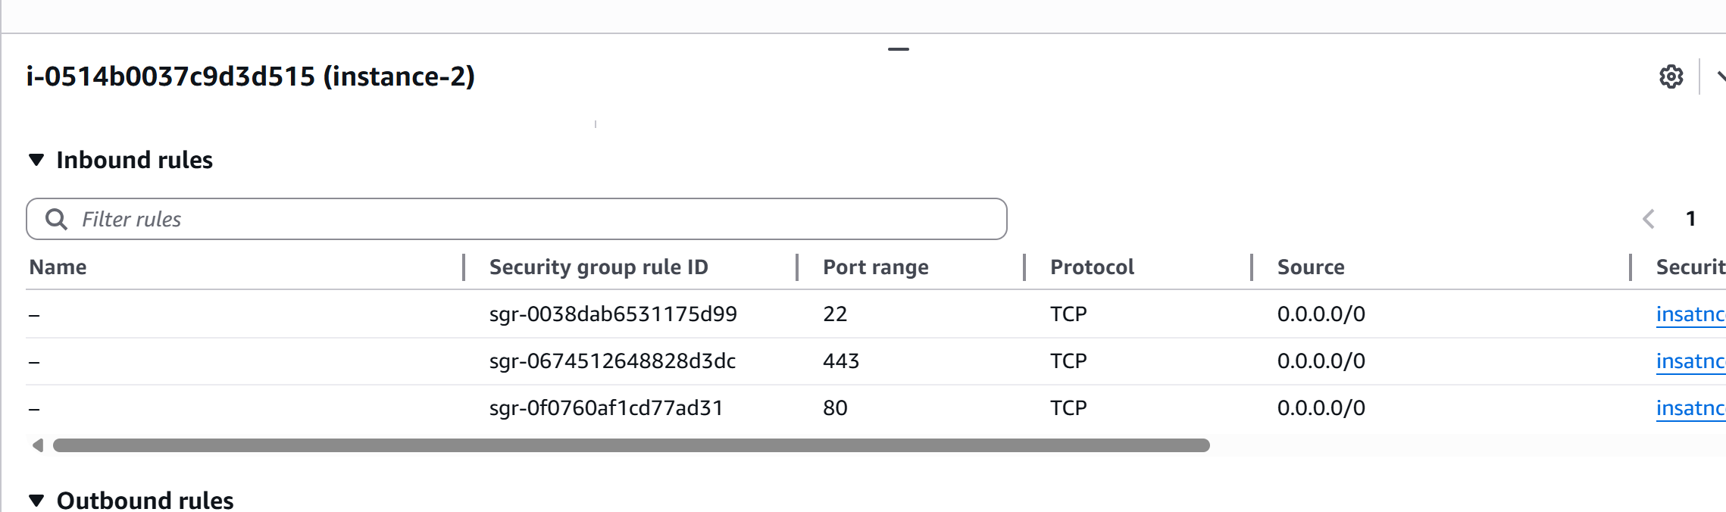

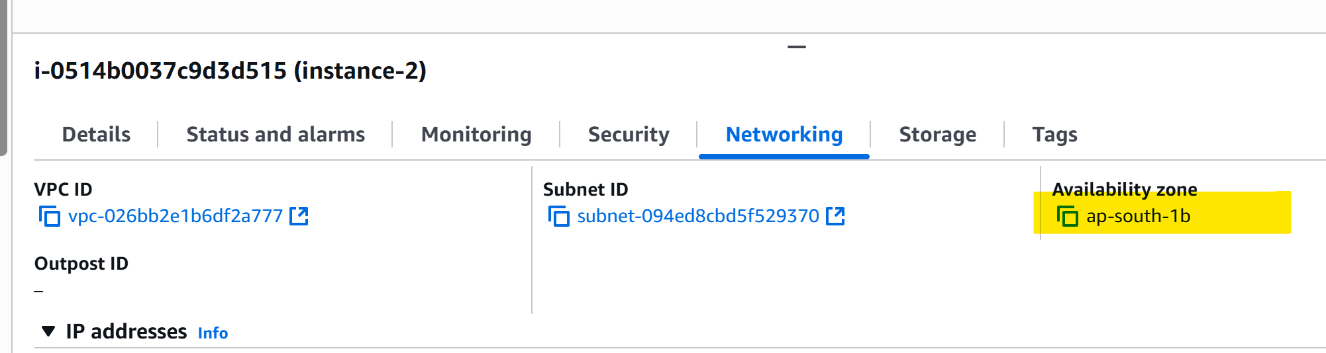

Installed APACHE

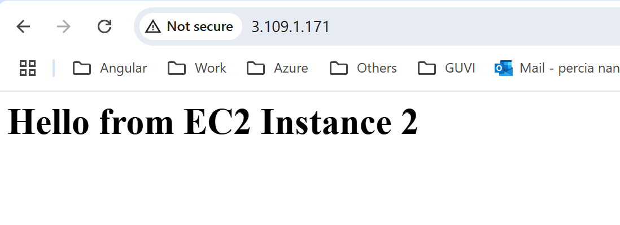

ALB

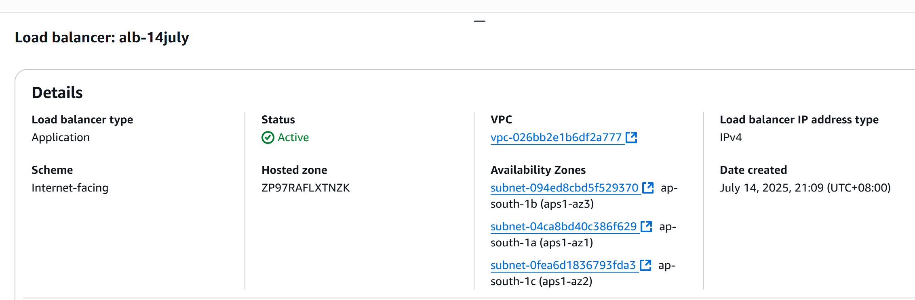

Target group

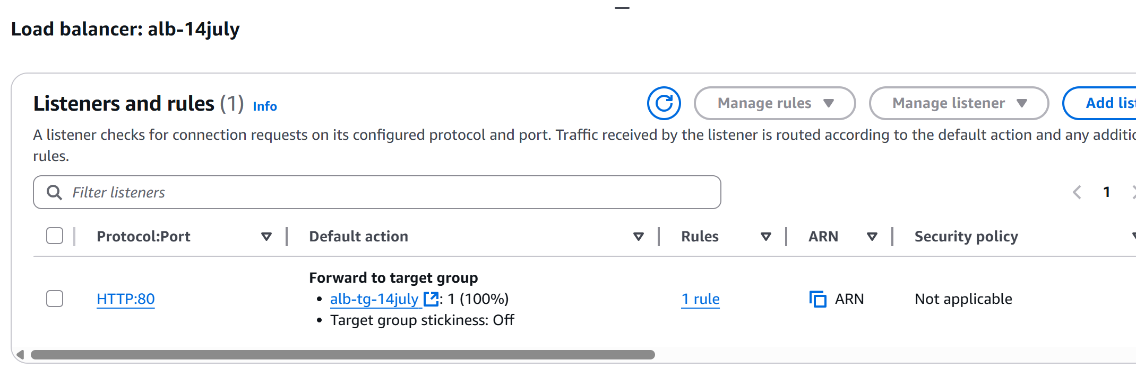

Registered 2 instance in target group  
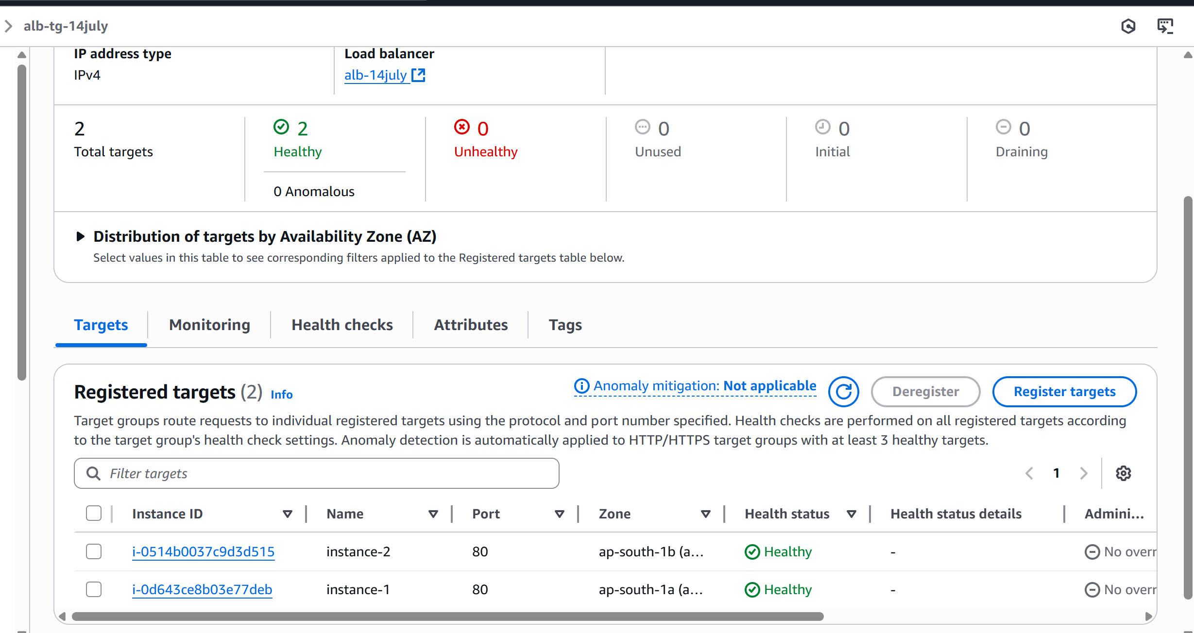

In security group allow port 80  
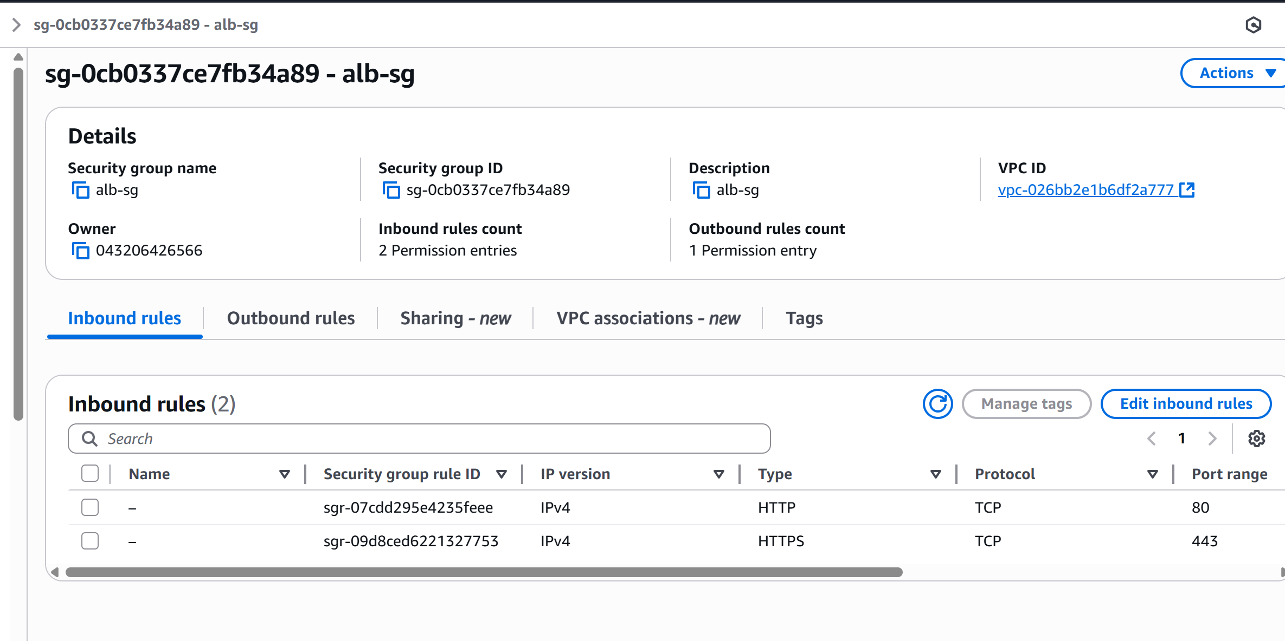

Once ALB is active, browse the ALB dns name in browser

Refresh the page multiple times , alternating responses

